“Python TSP”

**TSP Problem**

The Traveling Salesman Problem is one of the most intensively studied problems in computational mathematics. These pages are devoted to the history, applications, and current research of this challenge of finding the shortest route visiting each member of a collection of locations and returning to your starting point.

Given a set of cities and distance between every pair of cities, the problem is to find the shortest possible route that visits every city exactly once and returns to the starting point.

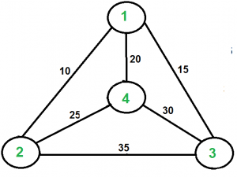

**Environment**

For this problem, our environment is a set of points or distances of the cities we want to get a trip. In this specific case, our environment are all the 32 states and are represented on a csv file.

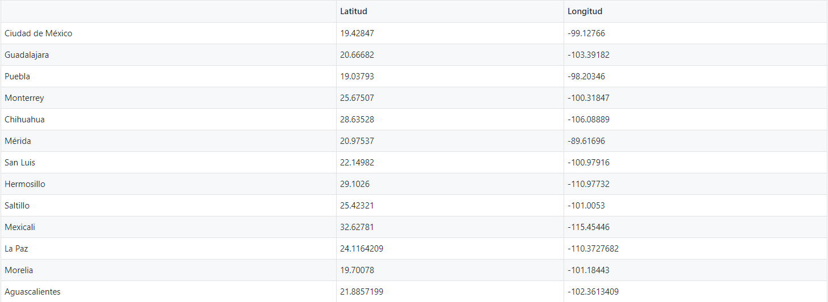

**Cost Function**

The Cost Function we propose here is based on the Geodesic Distance; a geodesic can be defined as a world-line that preserves tangency under parallel transport.

A curve can be specified by giving functions $x^{μ}$ (λ) for its coordinates.

Where:

* λ: is a real parameter.

A vector lying tangent to the curve can then be calculated using partial derivatives

$$T^{μ}=\frac{{∂x}^{μ}}{∂λ }$$

Basically, we only calculate the distance between two points in the latitude and longitude system. Then the fitness function is just the ∑ of the geodesic distances of the proposal of sites we want to visit.

**Genetic Algorithm**

A genetic algorithm is a search heuristic that is inspired by Charles Darwin’s theory of natural evolution. This algorithm reflects the process of natural selection where the fittest individuals are selected for reproduction in order to produce offspring of the next generation.

Five phases are considered in a genetic algorithm.

1. Initial population
2. Fitness function
3. Selection
4. Crossover
5. Mutation

1.- Initial Population.

The process begins with a set of individuals which is called a Population. Each individual is a solution to the problem you want to solve.

2.- Fitness Function

The fitness function determines how fit an individual is (the ability of an individual to compete with other individuals). It gives a fitness score to each individual. The probability that an individual will be selected for reproduction is based on its fitness score.

3.- Selection

The idea of selection phase is to select the fittest individuals and let them pass their genes to the next generation.

4.- Crossover

Crossover is the most significant phase in a genetic algorithm. For each pair of parents to be mated, a crossover point is chosen at random from within the genes.

Offspring are created by exchanging the genes of parents among themselves until the crossover point is reached.

5.- Mutation

In certain new offspring formed, some of their genes can be subjected to a mutation with a low random probability. This implies that some of the bits in the bit string can be flipped.

The algorithm terminates if the population has converged (does not produce offspring which are significantly different from the previous generation). Then it is said that the genetic algorithm has provided a set of solutions to our problem.

**YouTube Video**

References:

* Traveling Salesman Problem. (2020). Retrieved 19 October 2020, from <http://www.math.uwaterloo.ca/tsp/>
* Travelling Salesman Problem | Set 1 (Naive and Dynamic Programming) - GeeksforGeeks. (2020). Retrieved 19 October 2020, from <https://www.geeksforgeeks.org/travelling-salesman-problem-set-1/>
* Introduction to Genetic Algorithms — Including Example Code. (2020). Retrieved 19 October 2020, from <https://towardsdatascience.com/introduction-to-genetic-algorithms-including-example-code-e396e98d8bf3#:~:text=A%20genetic%20algorithm%20is%20a,offspring%20of%20the%20next%20generation>.
* 5.8: The Geodesic Equation. (2020). Retrieved 19 October 2020, from <https://phys.libretexts.org/Bookshelves/Relativity/Book%3A_General_Relativity_(Crowell)/05%3A_Curvature/5.08%3A_The_Geodesic_Equation#:~:text=Omitting%20some%20of%20the%20details,%2Bf%CB%99x%3D0>.